WEEK 1
- SingletonPattern Example

class Logger {

private static Logger instance;

private Logger(){
System.out.println("Instance created");
}

public static Logger getInstance() {
if(instance==null) {
instance = new Logger();
}
return instance;
}

public void log(String message) {
System.out.println("[LOG]"+message);
}

}
public class SingletonPattern {
public static void main(String[] args) {

Logger logger1 = Logger.getInstance();
Logger logger2 = Logger.getInstance();

logger1.log("Application started");
logger2.log("User Logged In");

if(logger1==logger2) {
System.out.println("Single Instance exists");
}else {
System.out.println("Multiple Instances exist");
}
}

}
OUTPUT:
Instance created
[LOG]Application started
[LOG]User Logged In
Single Instance exists

- FactoryMethodPattern Example
import java.util.*;

interface WordDocument{
void save();
}
interface PdfDocument{
void save();
}
interface ExcelDocument{
void save();
}
class Word implements WordDocument{
public void save(){
System.out.println("Word document saved");
}
}
class Pdf implements PdfDocument{
public void save(){
System.out.println("PDF document saved");
}
}
class Excel implements ExcelDocument{
public void save(){
System.out.println("Excel document saved");
}
}
abstract class DocumentFactory{
abstract DocumentFactory createDocument(String type);
}
class WordFactory extends DocumentFactory{
public Word createDocument(String type){
return new Word();
}
}
class PdfFactory extends DocumentFactory{
public Pdf createDocument(String type){
return new Pdf();
}
}
class ExcelFactory extends DocumentFactory{
public Excel createDocument(String type){
return new Excel();
}
}

class Test{
public static void main(String args[]){
DocumentFactory wordFactory = new WordFactory();
WordFactory word = wordFactory.createDocument("Word");
word.save();

DocumentFactory pdfFactory = new PdfFactory();
PdfFactory pdf = pdfFactory.createDocument("PDF");
pdf.save();

DocumentFactory excelFactory = new ExcelFactory();
ExcelFactory excel = excelFactory.createDocument("Excel");
excel.save();
}
}
OUTPUT
Word document saved
PDF document saved
Excel document saved

DATA STRUCTURES
- E-Commerce Platform Search Function

Asympotic notation (Big – O):
Big-O notation is used to represent the worst case time complexity of a solution. It is represented as O(). This helps us to estimate the time taken by solution to execute in worst case possible.
Best, Average and Worst cases for searches:
Linear Search:
Best case TC : O(1)
Average case TC : O(n/2) or O(n)
Worst case TC : O(n)
Binary Search:
Best case TC : O(1)
Average case TC : O(log n)
Worst case TC : O(log n)
Hashing:
Best case TC : O(1)
Average case TC : O(1)
Worst case TC : O(n)
Implementation:
import java.util.Arrays;
import java.util.Collections;
import java.util.Scanner;

class Product{
int productId;
String productName;
String category;

Product(int productId, String productName, String category){
this.productId = productId;
this.productName = productName;
this.category = category;
}
static void linearSearch(Product[] products,int k){
long startTime = System.nanoTime();
for(int i=0;i<products.length;i++){
if(products[i].productId == k){
System.out.println("Product found: " + products[i].productName + ", Category: " + products[i].category);
System.out.println("Time taken:" + (System.nanoTime() - startTime) + " nanoseconds");
return;
}
}
System.out.println("Product not found");
}
static void binarySearch(Product[] products,int k){
long startTime = System.nanoTime();
int left = 0,right = products.length-1;
while(left<=right){
int mid = left + (right-left)/2;
if(products[mid].productId == k){
System.out.println("Product found: " + products[mid].productName + ", Category: " + products[mid].category);
System.out.println("Time taken:" + (System.nanoTime() - startTime) + " nanoseconds");
return;
}else if(products[mid].productId < k){
left = mid + 1;
}else{
right = mid - 1;
}
}
System.out.println("Product not found");
System.out.println("Time taken:" + (System.nanoTime() - startTime) + " nanoseconds");
}
public static void main(String[] args) {
Scanner od = new Scanner(System.in);
int n = od.nextInt();
Product[] products = new Product[n];
for(int i=0; i<n; i++){
int productId = od.nextInt();
String productName = od.next();
String category = od.next();
products[i] = new Product(productId, productName, category);
}
Collections.sort(Arrays.asList(products),(p1,p2)->Integer.compare(p1.productId,p2.productId));
int k = od.nextInt();
linearSearch(products, k);
binarySearch(products, k);
}
}

OUTPUT
Product found: dhg, Category: ijk
Time taken:3157600 nanoseconds (linear search)

Product found: dhg, Category: ijk
Time taken:85000 nanoseconds (binary search)

- Financial Forecast
Recursion:
Recursion is a programming technique where a method calls itself to solve a smaller instance of the same problem until it reaches a base case, where recursion stops.
A recursive function has two parts:
- Base Case – Stops the recursive calls.
- Recursive Case – Calls the function with a smaller or simpler input.
Recursion simplifies problems that can be broken into smaller sub problems.
import java.util.Scanner;

class FinancialForecast{
public static double calculateGrowthRate(double[] pastData){
return calculateGrowthRate(pastData, 1, 0.0);
}

private static double calculateGrowthRate(double[] pastData, int index, double sum){
if(index >= pastData.length){
return sum / (pastData.length - 1);
}
double growth = (pastData[index] - pastData[index - 1]) / pastData[index - 1];
return calculateGrowthRate(pastData, index + 1, sum + growth);
}

public static void main(String args[]){
Scanner od = new Scanner(System.in);
System.out.println("Enter the number of past years of financial data:");
int n = od.nextInt();
double[] pastData = new double[n];
System.out.println("Enter the financial data for the past " + n + " years:");
for(int i=0;i<n;i++){
pastData[i] = od.nextDouble();
}

double growthRate = calculateGrowthRate(pastData);
System.out.println("Growth rate after analysis of past data is: " + growthRate);
System.out.println("Enter the number of years for which you want to forecast:");
int forecastYears = od.nextInt();
double lastYearData = pastData[n-1];
System.out.println("Forecasted financial data for the next " + forecastYears + " years:");
forecast(lastYearData, growthRate, n + 1, n + forecastYears);
}

private static void forecast(double currentValue, double growthRate, int currentYear, int endYear){
if(currentYear > endYear){
return;
}
double nextValue = currentValue + currentValue * growthRate;
System.out.println("Year " + currentYear + ": " + nextValue);
forecast(nextValue, growthRate, currentYear + 1, endYear);
}
}
OUTPUT
Enter the number of past years of financial data:
3
Enter the financial data for the past 3 years:
1210
1331
1464
Growth rate after analysis of past data is: 0.09996243425995492
Enter the number of years for which you want to forecast:
4
Forecasted financial data for the next 4 years:
Year 4: 1610.345003756574
Year 5: 1771.3190103304373
Year 6: 1948.384370454002
Year 7: 2143.1496149986338

Time Complexity of the Recursive Algorithm

1. calculateGrowthRate(pastData, index + 1, sum + growth);
- The recursive function visits each element of the pastData array exactly once.
- If there are n years of past financial data, the function makes n − 1 recursive calls.
Time Complexity: O(n)
Space Complexity: O(n) because each recursive call occupies one stack frame.

2. forecast(nextValue, growthRate, currentYear + 1, endYear);
- The function makes one recursive call for each future year to be predicted.
- If m future years are forecasted, it performs m recursive calls.
Time Complexity: O(m)
Space Complexity: O(m)

Overall Complexity
If:
- n = number of past years
- m = number of future years to forecast
Then,
- Overall Time Complexity: O(n + m)
- Overall Space Complexity: O(n + m) (due to the recursion stack)
Optimization to Avoid Excessive Computation
Although the current recursive solution is efficient because each recursive call performs a unique computation, recursion consumes additional memory for the call stack. The following optimizations can be used:

1. Use Iteration Instead of Recursion
Replace the recursive forecast() method with a simple for loop. This produces the same output while reducing the space complexity from O(m) to O(1) because no recursive stack is created.

2. Store Intermediate Results (Memoization)
If the forecasting algorithm becomes more complex and repeatedly computes the same values, memoization can be used to store previously calculated results. This avoids redundant calculations and improves performance.

3. Validate Input Data
Ensure that:
- At least two years of historical data are provided.
- Previous year's value is not zero before calculating the growth rate, preventing division-by-zero errors.

4. Tail Recursion
The forecast() method is already a tail-recursive function because the recursive call is the last statement. Some programming languages optimize tail recursion to avoid growing the call stack. However, Java does not perform tail-call optimization, so using an iterative approach is generally more memory-efficient.

PL/SQL

- Control Structures

Scenario 1: Apply 1% Discount to Loan Interest Rates for Customers Above 60
SET SERVEROUTPUT ON;

DECLARE
CURSOR c_customers IS
SELECT c.CustomerID, c.DOB, l.LoanID, l.InterestRate
FROM Customers c
JOIN Loans l ON c.CustomerID = l.CustomerID;

v_age NUMBER;
BEGIN
FOR rec IN c_customers LOOP

v_age := FLOOR(MONTHS_BETWEEN(SYSDATE, rec.DOB) / 12);

IF v_age > 60 THEN
UPDATE Loans
SET InterestRate = InterestRate - 1
WHERE LoanID = rec.LoanID;

DBMS_OUTPUT.PUT_LINE('Discount applied to Customer ID: ' || rec.CustomerID);
END IF;

END LOOP;

COMMIT;
END;
/

Scenario 2: Promote Customers to VIP
SET SERVEROUTPUT ON;

BEGIN

FOR rec IN (SELECT CustomerID, Balance FROM Customers) LOOP

IF rec.Balance > 10000 THEN
UPDATE Customers
SET IsVIP = 'Y'
WHERE CustomerID = rec.CustomerID;

DBMS_OUTPUT.PUT_LINE('Customer ' || rec.CustomerID || ' promoted to VIP.');
END IF;

END LOOP;

COMMIT;
END;
/

Scenario 3: Send Loan Due Reminders
SET SERVEROUTPUT ON;

BEGIN

FOR rec IN (
SELECT c.Name, l.LoanID, l.EndDate
FROM Customers c
JOIN Loans l
ON c.CustomerID = l.CustomerID
WHERE l.EndDate BETWEEN SYSDATE AND SYSDATE + 30
)
LOOP

DBMS_OUTPUT.PUT_LINE(
'Reminder: Dear ' || rec.Name ||
', your Loan ID ' || rec.LoanID ||
' is due on ' || TO_CHAR(rec.EndDate,'DD-MON-YYYY')
);

END LOOP;

END;
/

- Stored Procedures

Scenario 1: Process Monthly Interest
CREATE OR REPLACE PROCEDURE ProcessMonthlyInterest
IS
BEGIN
UPDATE Accounts
SET Balance = Balance + (Balance * 0.01),
LastModified = SYSDATE
WHERE AccountType = 'Savings';

COMMIT;

END;
/

Execute
BEGIN
ProcessMonthlyInterest;
END;
/

Scenario 2: Update Employee Bonus
CREATE OR REPLACE PROCEDURE UpdateEmployeeBonus(
p_department IN VARCHAR2,
p_bonusPercent IN NUMBER
)
IS
BEGIN

UPDATE Employees
SET Salary = Salary + (Salary * p_bonusPercent / 100)
WHERE Department = p_department;

COMMIT;

END;
/

Execute
BEGIN
UpdateEmployeeBonus('IT',10);
END;
/

Scenario 3: Transfer Funds
CREATE OR REPLACE PROCEDURE TransferFunds(
p_fromAccount IN NUMBER,
p_toAccount IN NUMBER,
p_amount IN NUMBER
)
IS
v_balance NUMBER;
BEGIN

SELECT Balance
INTO v_balance
FROM Accounts
WHERE AccountID = p_fromAccount
FOR UPDATE;

IF v_balance >= p_amount THEN

UPDATE Accounts
SET Balance = Balance - p_amount,
LastModified = SYSDATE
WHERE AccountID = p_fromAccount;

UPDATE Accounts
SET Balance = Balance + p_amount,
LastModified = SYSDATE
WHERE AccountID = p_toAccount;

COMMIT;

DBMS_OUTPUT.PUT_LINE('Transfer Successful.');

ELSE

DBMS_OUTPUT.PUT_LINE('Insufficient Balance.');

END IF;

EXCEPTION
WHEN NO_DATA_FOUND THEN
DBMS_OUTPUT.PUT_LINE('Invalid Account Number.');

WHEN OTHERS THEN
ROLLBACK;
DBMS_OUTPUT.PUT_LINE(SQLERRM);
END;
/

Execute
BEGIN
TransferFunds(1,2,500);
END;
/
JUnit and Mockito
1.Setting up Junit
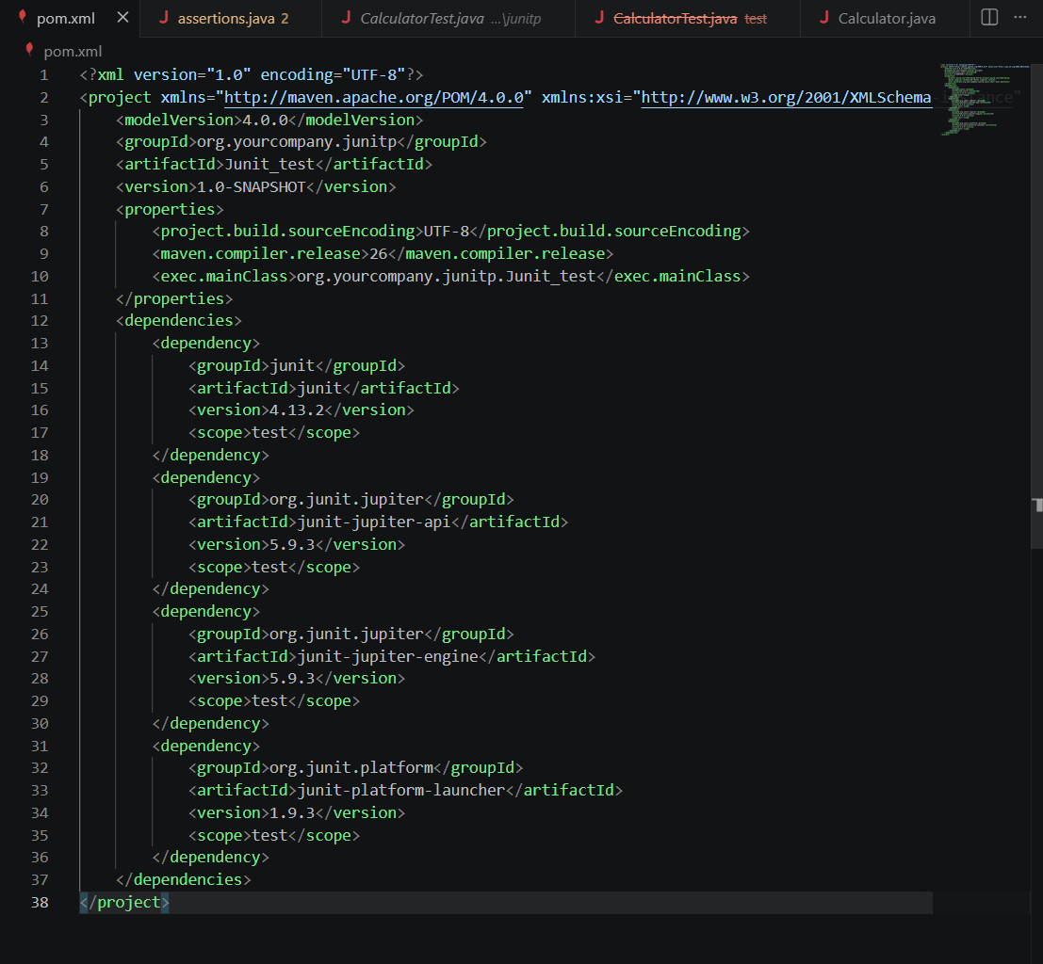
2.Assertion in Junit
package org.yourcompany.junitp;

import static org.junit.Assert.*;
import org.junit.Test;

class AssertionsTest {

@Test
public void testAssertions() {

// Assert Equals
assertEquals(5, 2 + 3);

// Assert True
assertTrue(5 > 3);

// Assert False
assertFalse(5 < 3);

// Assert Null
assertNull(null);

// Assert Not Null
assertNotNull(new Object());

// Assert Same
String s = "Hello";
assertSame(s, s);

// Assert Not Same
assertNotSame(new String("Hello"), new String("Hello"));

// Assert Array Equals
int[] expected = {1,2,3};
int[] actual = {1,2,3};
assertArrayEquals(expected, actual);
}
}
cd C:\Users\DELL\Junit_test; "JAVA_HOME=C:\\Program Files\\Java\\jdk-26.0.1" cmd /c "\"C:\\Users\\DELL\\.vscode\\extensions\\oracle.oracle-java-26.0.0\\nbcode\\java\\maven\\bin\\mvn.cmd\" -Dmaven.ext.class.path=C:\\Users\\DELL\\.vscode\\extensions\\oracle.oracle-java-26.0.0\\nbcode\\java\\maven-nblib\\netbeans-eventspy.jar --no-transfer-progress test"
WARNING: Final field _cipher in class org.sonatype.plexus.components.sec.dispatcher.DefaultSecDispatcher has been mutated reflectively by class org.eclipse.sisu.bean.BeanPropertyField in unnamed module @fdefd3f (file:/C:/Users/DELL/.vscode/extensions/oracle.oracle-java-26.0.0/nbcode/java/maven/lib/org.eclipse.sisu.inject-0.9.0.M4.jar)
WARNING: Use --enable-final-field-mutation=ALL-UNNAMED to avoid a warning
WARNING: Mutating final fields will be blocked in a future release unless final field mutation is enabled
Scanning for projects...
-----------------< org.yourcompany.junitp:Junit_test >------------------
Building Junit_test 1.0-SNAPSHOT
from pom.xml
--------------------------------[ jar ]---------------------------------
--- resources:3.3.1:resources (default-resources) @ Junit_test ---
skip non existing resourceDirectory C:\Users\DELL\Junit_test\src\main\resources
--- compiler:3.13.0:compile (default-compile) @ Junit_test ---
Nothing to compile - all classes are up to date.
--- resources:3.3.1:testResources (default-testResources) @ Junit_test ---
skip non existing resourceDirectory C:\Users\DELL\Junit_test\src\test\resources
--- compiler:3.13.0:testCompile (default-testCompile) @ Junit_test ---
Recompiling the module because of changed source code.
Compiling 2 source files with javac [debug release 26] to target\test-classes
--- surefire:3.2.5:test (default-test) @ Junit_test ---
Using auto detected provider org.apache.maven.surefire.junitplatform.JUnitPlatformProvider
-------------------------------------------------------
T E S T S
-------------------------------------------------------
Results:
Tests run: 0, Failures: 0, Errors: 0, Skipped: 0
------------------------------------------------------------------------
BUILD SUCCESS
------------------------------------------------------------------------
Total time: 2.374 s
Finished at: 2026-07-04T21:31:55+05:30
------------------------------------------------------------------------

3.Mocking and Stubbing
ExternalAPI.java:
package org.yourcompany.junitp;

public interface ExternalApi {
String getData();
}

MyService.java:
package org.yourcompany.junitp;

public class MyService {

private final ExternalApi api;

public MyService(ExternalApi api) {
this.api = api;
}

public String fetchData() {
return api.getData();
}

}

MyServiceTest.java:
package org.yourcompany.junitp;

import static org.junit.jupiter.api.Assertions.assertEquals;
import org.junit.jupiter.api.Test;
import org.mockito.Mockito;
import static org.mockito.Mockito.when;

public class MyServiceTest {

@Test
public void testExternalApi() {

// Step 1: Create mock object
ExternalApi mockApi = Mockito.mock(ExternalApi.class);

// Step 2: Stub method
when(mockApi.getData()).thenReturn("Mock Data");

// Step 3: Pass mock to service
MyService service = new MyService(mockApi);

// Call service method
String result = service.fetchData();

// Verify output
assertEquals("Mock Data", result);
}
}

SL4J :
Logging error and warning messages:
import org.slf4j.Logger;
import org.slf4j.LoggerFactory;
public class LoggingExample {
private static final Logger logger = LoggerFactory.getLogger(LoggingExample.class);
public static void main(String[] args) {
logger.error("This is an error message");
logger.warn("This is a warning message");
}
}
OUTPUT:
--- exec:3.5.1:exec (default-cli) @ Junit_test ---
10:28:12.287 [main] ERROR LoggingExample - This is an error message
10:28:12.292 [main] WARN LoggingExample - This is a warning message
------------------------------------------------------------------------
BUILD SUCCESS
------------------------------------------------------------------------
Total time: 1.847 s
Finished at: 2026-07-07T10:28:12+05:30
------------------------------------------------------------------------

